
LEGENDS ACADEMY
2017-18

Instructional Focus:

What are your identified areas of instruction to focus on this year?
- Reading - Comprehension
- Math – Foundational Skill Mastery
- Immediate Academic Feedback

Is this tied to this year’s professional development? Yes

If so, how?
Our teachers receive at minimum at least 12 hours of professional development (PD) and coaching on how to improve and assess their instructional practice related to the Florida standards. With a strategic focus on both rigorous assessments and on-going progress monitoring we are able to target and identify academic deficiencies with greater accuracy.

PROFESSIONAL DEVELOPMENT AT LEGENDS ACADEMY – RESULTS DRIVEN

How do we effectively use our curriculum resources to teach the standards?

Do we have rigorous and authentic assessments that inform us of our scholars understanding of the Florida Standards?

How do we analyze data effectively in order to move scholar achievement and teacher practice?
What professional development is necessary to ensure that our teachers acquire and consistently improve their instructional practices so that ALL scholars acquire the skills necessary to master the Florida Standards?

School Climate ● Observations and Feedback ● Development of Formative Assessments ● Lesson Planning with Colleagues ● Peer Coaching ● Classroom Walkthroughs ● Data Chats

Are you having any challenges with providing adequate professional development? None

In the FL statute professional learning is referred to as in-service activities [Florida Statutes (2007) Section 1012.98.4(b)3]. The statute requires that a school district’s professional learning for instructional personnel focus on the following eight categories:
Analysis of student achievement data
We meet at minimum every 3 weeks to analyze student achievement data. Our on-going progress monitoring includes a very structured MTSS process.

Ongoing formal and informal assessments of student achievement
Embedded in the resources we use are formative and summative assessments that allow us to progress monitor student achievement.

Identification and use of enhanced and differentiated instructional strategies that emphasize rigor, relevance, and reading in the content areas
This is an area of focus for our school and so we have a very rigorous model that provides multiple levels of tiered support for students. Each reading block has a pacing guide with small teacher led student groups that are differentiated based on mastery of core reading skills and standards. In addition, our support staff are trained on very specific components of intervention so that they pull small groups of students focusing on specific skills.

Enhancement of subject content expertise
Our leadership team is part of the Relay Graduate Program developed by Uncommon schools. We actively participate in on-going professional development modules designed to increase content expertise.

Integration of classroom technology that enhances teaching and learning
Each KG – 4th grade classroom has 5 computers: 4 for student use and 1 for the teacher. Students in 3rd - 7th grade have access to one to one technology. Our 5th – 7th grade classrooms have interactive smart boards.

In addition, we utilize technology based instructional programs such as Lexia and iReady

Classroom management
Our Director and Social Emotional Specialist work directly with teachers on their classroom management plan and provide coaching and on-going professional development in this area. Our leadership team completed the Restorative Justice training and has incorporated components into our overall KIND community Positive Behavioral Support System.

Parent involvement
We hold family empowerment activities that include: Open House, Conference Nights, Literacy Workshops, STE’A’M Nights and Health and Wellness/Nutrition Workshops.

School safety
We maintain gates and a buzzed entry into the school campus with security cameras throughout.

CHARTER CONTRACT GOALS

Overall Goal: Closing the Achievement Gap

Increasing instructional time

We have an additional 4 hours of instructional time each week. We accomplished this through the extension of the school day by one hour on Monday, Tuesday, Thursday and Friday. Therefore, we have an additional 30 minutes of math each day.

Each student is expected to make a year’s worth of growth in a year’s worth of time

We have multiple resources that allow us to evaluate student growth and progress based on grade level standards. These assessments are administered at the beginning, middle and end of the year. Several are also used as part of our on-going progress monitoring.

Reading: NWEA-MAP, Lexia, iReady, Leveled Literacy Intervention (LLI), SIPPS, Mini-Assessments (Unify)
Math: NWEA-MAP, iReady, Mini-Assessments (Unify), Key Math

Student progress and performance will be evaluated using performance measures.

We are consistently evaluating our data and making adjustments to our instruction based on student performance. We meet every 2 to 3 weeks to make decisions regarding students needing tiered support, resources/materials, teacher support/coaching, and any modifications that need to be made to the instructional plan.
(68%)

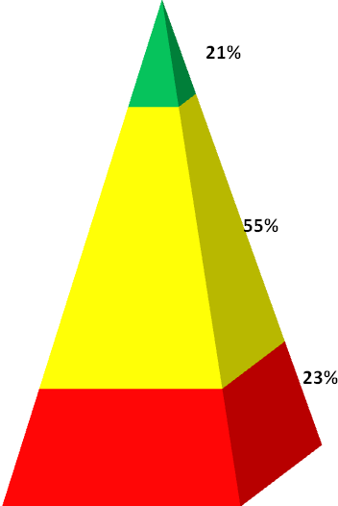
Assessment of all incoming students to establish a performance baseline.

We are using iReady as well as NWEA-MAP to establish an academic performance baseline. The illustrations below are based on the iReady Diagnostic.
READING

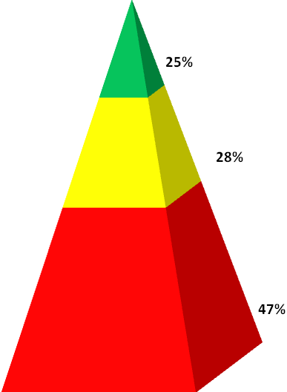
Tier 1
Tier 1
(10%)
MATH
(8%)

Tier 2
(24%)
Tier 2
(28%)

Tier 3
Tier 3
(62%)
FSA GOAL SETTING

FSA RESULTS SPRING 2017
 | READING |  |  |  | MATH |  |  | SCIENCE
SCHOOL | ELA Achievement | ELA Learning Gains | Low 25% ELA Learning Gains |  | Math Achievement | Math Learning Gains | Low 25% Math Learning Gains | Science Achievement | Total Points Earned |  | Percent of Possible Points |  | Projected School Grade
LEGENDS ACADEMY | 32 | 49 | 76 |  | 36 | 53 | 57 | 17 | 320 |  | 46 |  | C
NAP FORD | 49 | 68 | 64 |  | 53 | 58 |  | 47 | 339 |  | 57 |  | B
ARBOR RIDGE K-8 | 79 | 73 | 68 |  | 84 | 82 | 75 | 66 | 716 |  | 80 |  | A
BLANKNER K-8 | 73 | 65 | 55 |  | 78 | 77 | 62 | 75 | 664 |  | 74 |  | A
FSA GOALS 2018
 | ELA Achievement | ELA Learning Gains | Low 25% ELA Learning Gains | Math Achievement |  | Math Learning Gains | Low 25% Math Learning Gains | Science Achievement |  | Total Points Earned |  | Percent of Possible Points |  | Projected School Grade
LEGENDS ACADEMY | 55% | 70% | 75% | 55% |  | 70% | 70% | 50% |  | 445 |  | 64% |  | A

Participation in any newly adopted state requirements, such as End of Course exams.

We will participate in all state required assessments.

